RUTHERGLEN  Rutherglen Town Hall  139 Main Street  Rutherglen G73 2JJ  Tues 4th Aug – 8th Sept  6:00pm – 7:30pm | HAMILTON  UWS - Hamilton  Almada Street  Hamilton ML3 OJB  Wed 19th Aug–23rd Sept  2:30pm – 4:00pm | COATBRIDGE  Coatbridge College  Kildonan Street  Coatbridge ML5 3LS  Thurs 20th Aug – 24th Sept  6:00pm – 7:30pm | MOTHERWELL  Hope United Church  98 Orbiston Street  Motherwell ML1 1PX  Thurs 3rd Sept – 8th Oct  1:00pm – 2:30pm
CUMBERNAULD  Cumbernauld College  Town Centre  Cumbernauld G67 1HU  Wed 9th Sept – 7th Oct  6:00pm – 7:30pm | CLYDESDALE  Carluke Health Centre  40 Chapel Street  Carluke ML8 4BA  Mon 5th Oct – 16th Nov  09:30am – 11:00am | WISHAW  Motherwell College  1 Enterprise Way  Motherwell ML1 2TX  Mon 5th Oct – 16th Nov  6:00pm – 7:30pm | EAST KILBRIDE  Lecture Theatre Hairmyres  Eaglesham Road  East Kilbride G75 8RG  Thurs 8th Oct – 12th Nov  6:00pm – 7:30pm
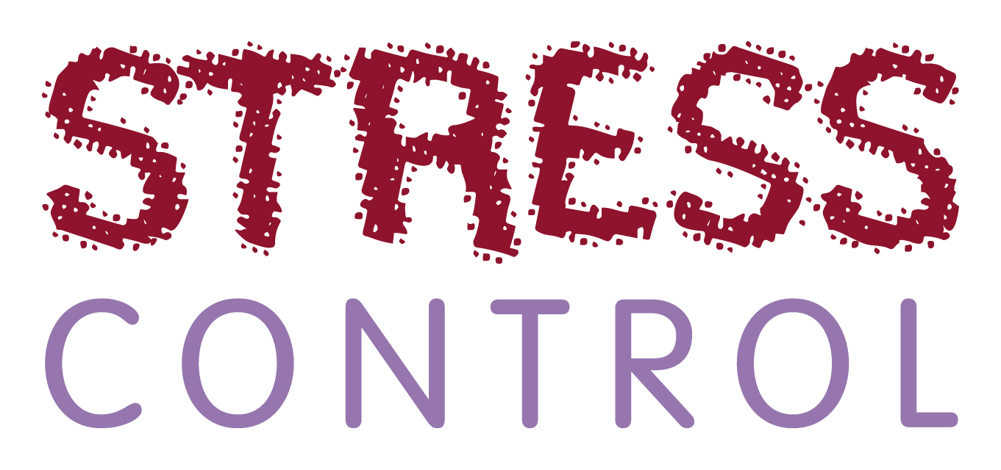


Find your nearest class and book a free place: 0300 303 0447
or email: stresscontrol@lanarkshire.scot.nhs.uk

Stress Control classes will help us develop skills
and techniques to manage common issues caused by modern day living such as stress, anxiety or low confidence, which can affect well-being.
The classes are delivered in local community facilities and consist of six sessions lasting 90 minutes each. We will not need to speak about our issues during the class. Just sit back and listen about helpful stress control techniques*. Feel free to bring someone along with you for support.
* Some of the issues covered during the sessions are:
• Information about stress • Boosting your self confidence
• How to control your body • Controlling panic
• How to control your thoughts • Controlling sleep problems

